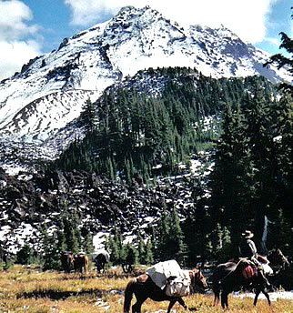
  - Working to Maintain Access to Public Lands
&
  - Encourage Wise Use of Back Country Resources through Education
  - www.bcho.org

Who We Are

BACK COUNTRY
HORSEMEN
OF OREGON
501(c)(3) Non-Profit

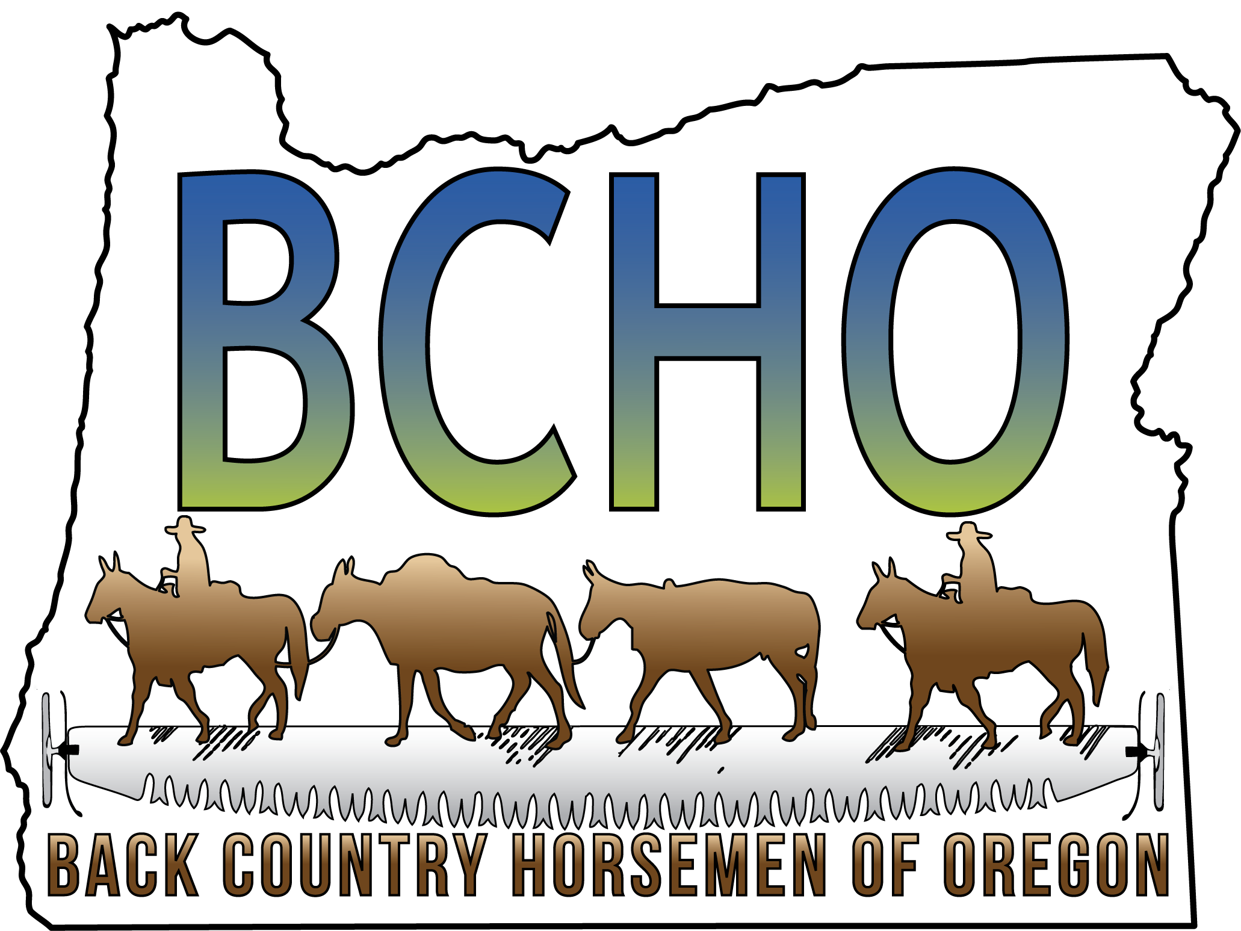
We are 10 local chapters in Oregon, and one of 23 recognized State Organizations of Back Country Horsemen of America. We promote and teach Leave No Trace ethics (LNT) and lobby for continued access of pack and saddle stock in Oregon's backcountry.
Back Country Horsemen of America was started in 1973 in Montana by a group of concerned horsemen. Our founders were concerned about horsemen being able to continue to have access to public lands. Back Country Horsemen was founded and adopted the following five principles on which everything we do is based.
Dedicated to Keeping Oregon’s Trails Open for All
- To perpetuate the common sense use and enjoyment of horses and mules in America’s back country and Wilderness.
- To work to ensure that public lands remain open to recreational stock use.
- To assist the various government agencies in their maintenance and management of said resources.
- To educate, encourage and solicit active participation in the wise use of the back country resource by horsemen and the general public commensurate with our heritage.
- To foster and encourage the formation of new state Back Country Horsemen’s organizations.
What we do
Back Country Horsemen understands that we have to actively work with all city, state and federal government agencies to maintain equestrian access to public lands. Back Country Horsemen accomplishes this by attending and speaking at public meetings, writing letters, and working with our government agencies to maintain many wilderness and non-wilderness trails in the state of Oregon. Our local chapters work, with the blessing and support of the public agencies, all over the state. We provide training in LNT principals and techniques to minimize our equestrian impact on the backcountry. Each year Back Country Horsemen of Oregon does volunteer work in the state of Oregon valued at $500,000.00.
It’s not just all work
Back Country Horsemen also engage in fun, family activities! All chapters have various rides, fundraisers, speakers with equestrian interests, campouts and social gatherings throughout the year. If you are seeking people to ride with in your area, coming to a chapter meeting is a great place to meet people with common interests.
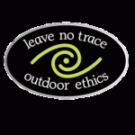
How you can help
Join… The voice of one person standing alone is not often heard. As a State and National organization, 16,000 members strong, working with land managers, law makers and other user groups we can help preserve the horsemen's rights to the recreational use of stock on public lands. Back Country Horsemen of Oregon invites you to become actively involved in preserving your backcountry stock use by joining the BCHO Chapter nearest you. If no Chapter exists in your area you may join independently or create a new chapter.
Donate... Any and all donations go to helping maintain access to public lands.

Territorial Riders BCHO

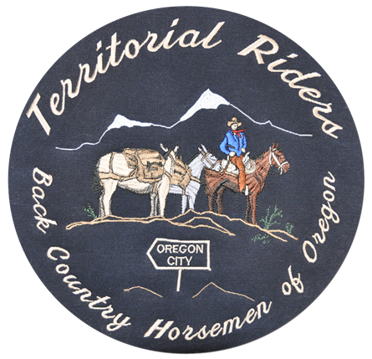

Chapter meetings are held on the second Tuesday of every month at the Beavercreek Fire Station, 22310 S Beavercreek Rd. Beavercreek, OR. 97004.
Meetings start at 7 PM.

facebook.com/TerritorialRidersBCHO
Who We Are
The Territorial Riders Chapter of BCHO was formed in 2012 when the original Territorial Riders Riding Club decided to do more to protect our trails, and trail access by joining forces with Back Country Horsemen. We are currently the second largest chapter in BCHO, and we are continuing to welcome new members to help us in our efforts to fulfill the mission of Back Country Horsemen.
Keeping the Trails Open
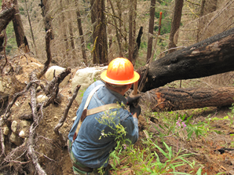
Territorial Riders adopted the Bull of the Woods Wilderness in 2012 and is now responsible for maintaining the 40+ miles of trails in the wilderness area. We are also active in helping to maintain the Pacific Crest Trail by maintaining the 6 mile section of trail from Joe Graham Campground to Little Crater Lake.
Giving Back
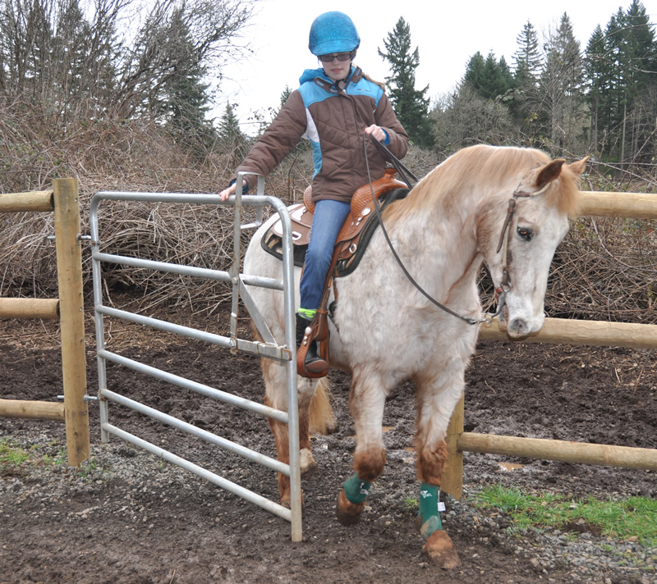
Territorial Riders BCHO holds an annual Poker ride in early July every year to raise funds to continue working with our partners and government agencies to improve riding areas. In 2012, Territorial Riders provided the materials for the equine training stations installed at McIver Park.

Become a TRBCHO member!
Membership Application
Yes! I would like to help preserve Horsemen’s rights to use stock on public lands.
____________________________________
(Print Name)

____________________________________
(Address)

____________________________________
(City) (State) (ZIP)

____________________________________
(Telephone) (E–Mail)

Territorial Riders BCHO Membership Dues
Single $35.00 _________
Family $45.00 _________
(Additional Chapter dues may be determined by individual Chapters)
Liability Release: Recognizing the fact that there is a potential for an accident where ever horse use is involved, which can cause injuries to horses, riders and spectators, and also recognizing that Back Country Horsemen of Oregon, Inc., including its chapters, officers, directors and or members cannot know the condition of trails or the experience of riders or horses taking part in trail rides or other Back Country Horsemen of Oregon functions, I do hereby release Back Country Horsemen of Oregon, Inc., its officers, directors and members from any claim or right for damages which might occur to me, my minor children or horses.
Signed___________________________________
Date______________________
MAIL your application to:
Territorial Riders BCHO
35408 S. Sawtell Rd.
Molla Or. 97038-9703
Make checks payable to BCHO.

