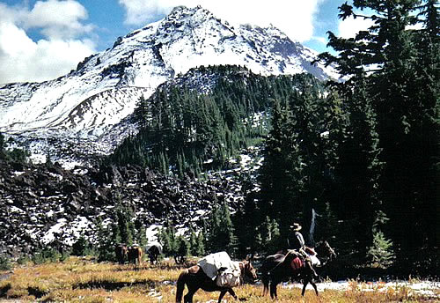

**Working to Maintain Access to Public Lands  
&**

**Encourage Wise Use of Back Country Resources through Education**

***www.bcho.org***

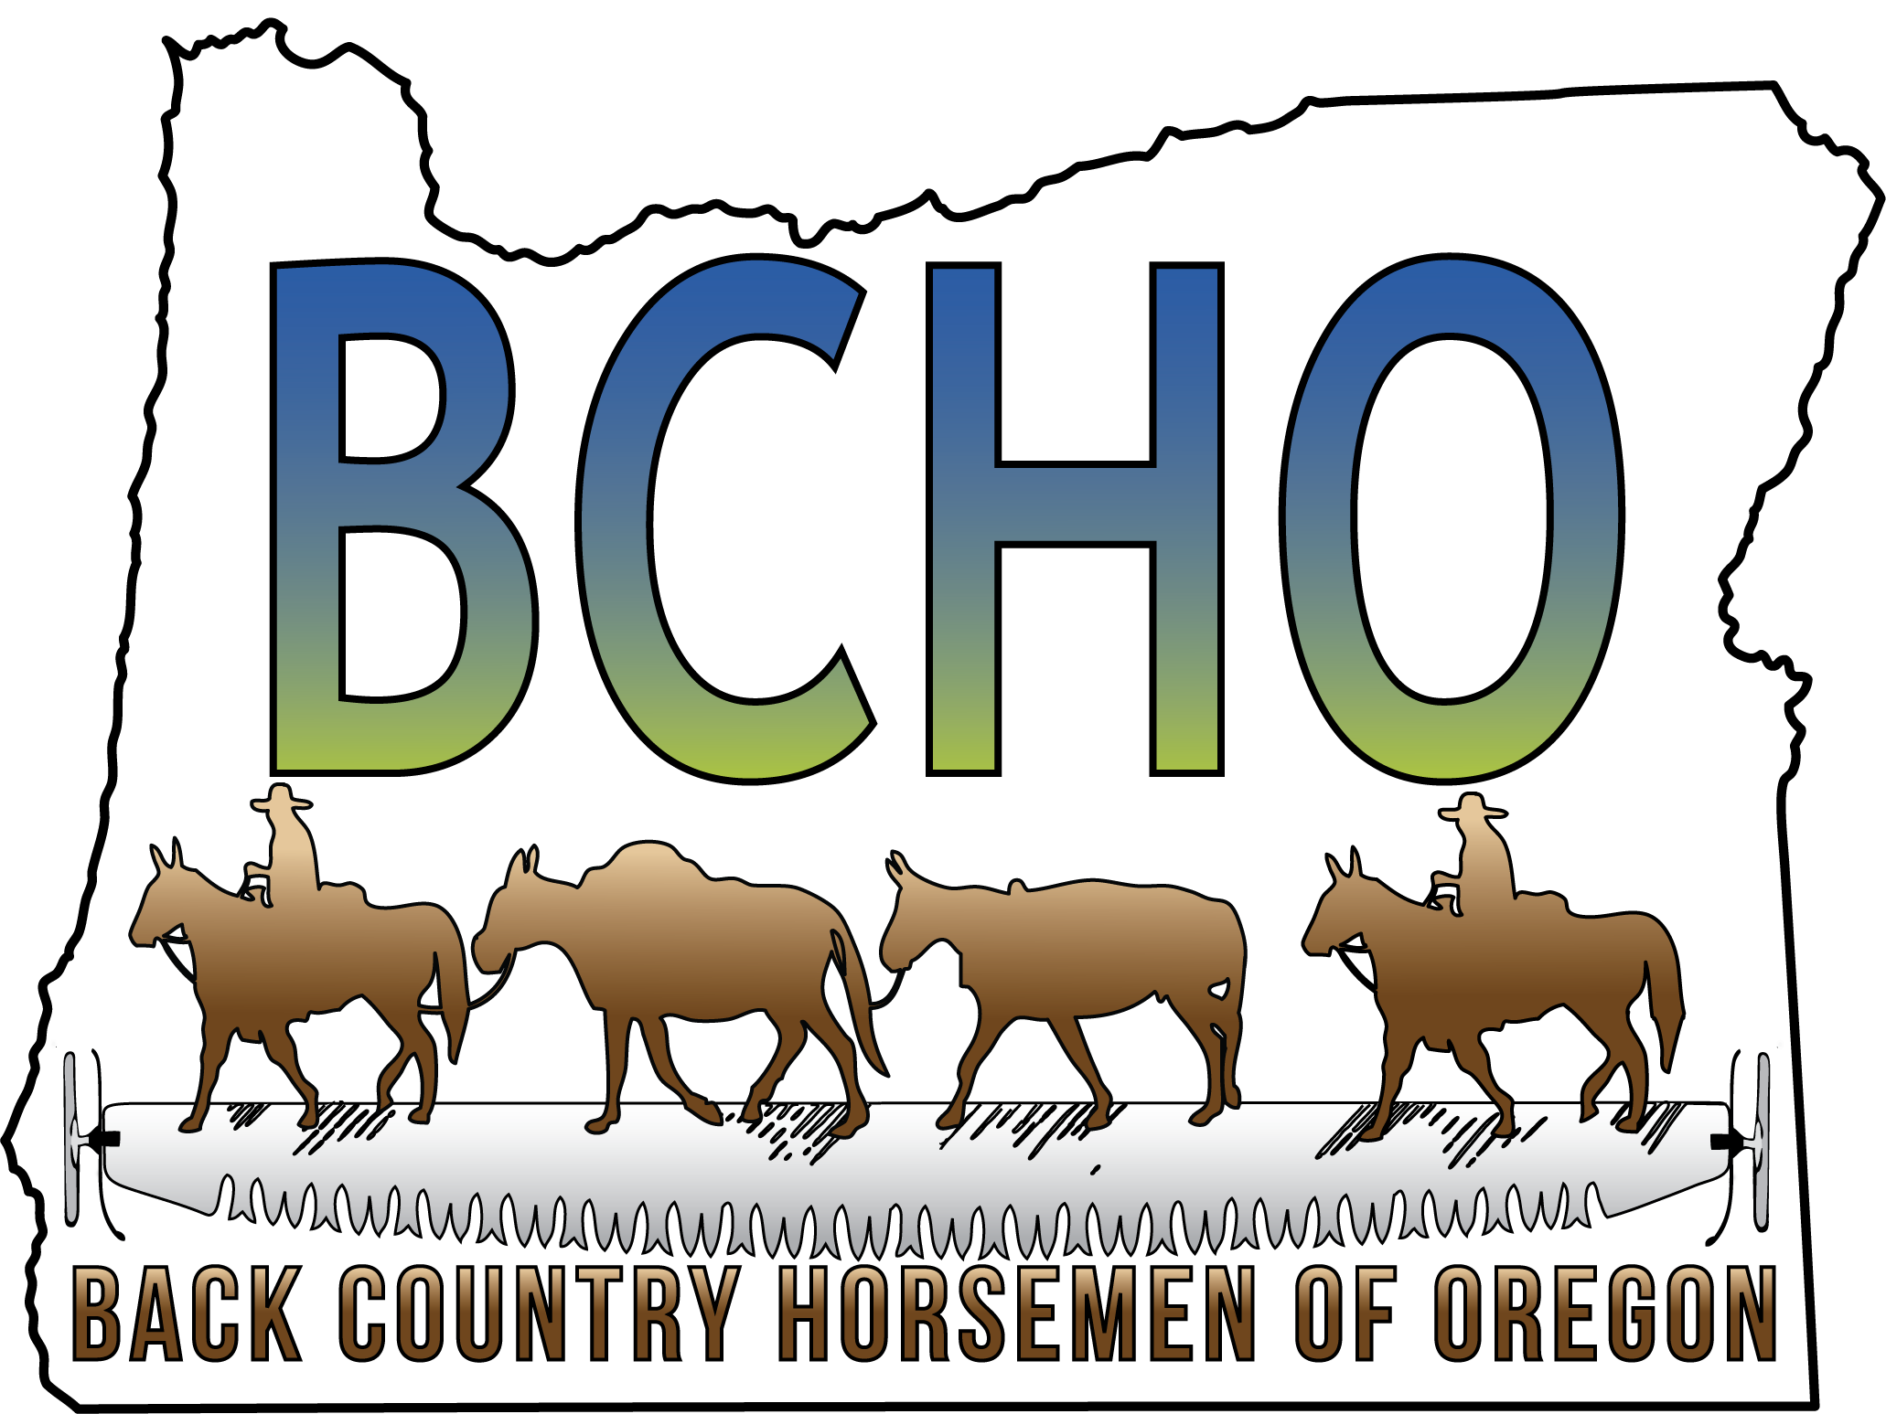Who We Are

BACK COUNTRY  
HORSEMEN   
OF OREGON  
501(c)(3) Non-Profit

We are 9 local chapters in Oregon, and one of 23 recognized State Organizations of Back Country Horsemen of America. We promote and teach Leave No Trace ethics (LNT) and lobby for continued access of pack and saddle stock in Oregon's backcountry.

Back Country Horsemen of America was started in 1973 in Montana by a group of concerned horsemen. Our founders were concerned about horsemen being able to continue to have access to public lands. Back Country Horsemen was founded and adopted the following five principles on which everything we do is based.

Dedicated to Keeping Oregon’s Trails Open for All

* To perpetuate the common sense use and enjoyment of horses and mules in America’s back country and Wilderness.
* To work to ensure that public lands remain open to recreational stock use.
* To assist the various government agencies in their maintenance and management of said resources.
* To educate, encourage and solicit active participation in the wise use of the back country resource by horsemen and the general public commensurate with our heritage.
* To foster and encourage the formation of new state Back Country Horsemen’s organizations.

What we do

Back Country Horsemen understands that we have to actively work with all city, state and federal government agencies to maintain equestrian access to public lands. Back Country Horsemen accomplishes this by attending and speaking at public meetings, writing letters, and working with our government agencies to maintain many wilderness and non-wilderness trails in the state of Oregon. Our local chapters work, with the blessing and support of the public agencies, all over the state. We provide training in LNT principals and techniques to minimize our equestrian impact on the backcountry. Each year Back Country Horsemen of Oregon does volunteer work in the state of Oregon valued at $500,000.00.

It’s not just all work

Back Country Horsemen also engage in fun, family activities! All chapters have various rides, fundraisers, speakers with equestrian interests, campouts and social gatherings throughout the year. If you are seeking people to ride with in your area, coming to a chapter meeting is a great place to meet people with common interests.

How you can help

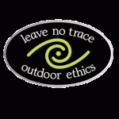***Join…*** The voice of one person standing alone is not often heard. As a State and National organization, 16,000 members strong, working with land managers, law makers and other user groups we can help preserve the horsemen's rights to the recreational use of stock on public lands. Back Country Horsemen of Oregon invites you to become actively involved in preserving your backcountry stock use by joining the BCHO Chapter nearest you. If no Chapter exists in your area you may join independently or create a new chapter.

***Donate...*** Any and all donations go to helping maintain access to public lands.

**BCHO Chapters**

Our chapters are key to our success through their efforts with our limited resources of time and people. Each chapter strives to keep their actions and activities relating directly to the original BCH purposes, at the same time offering family oriented events, rides and equestrian education throughout Oregon. The Annual Horse Packing and Wilderness Skills Clinic, is the best family educational equestrian event of its kind on the West Coast. It is put on every year by our largest chapter, the High Desert Trail Riders BCH the first weekend in May in Klamath Falls, www.bcho.org/hdtrbch.html. 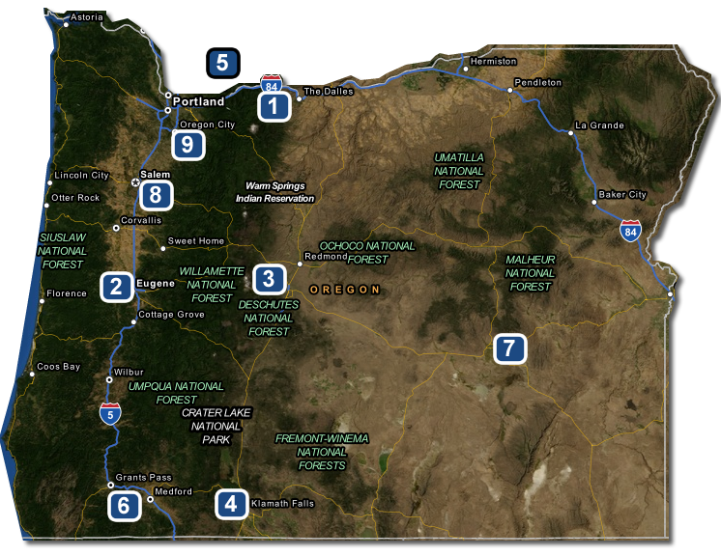

1. [Columbia Gorge BCH](http://bcho.org/wp/), Hood River area, contact columbiagorge@bcho.org
2. [Emerald Empire BCH](http://bcho.org/wp/), Eugene area, contact emeraldempire@bcho.org
3. [East Cascades BCH](http://bcho.org/wp/), Bend area, contact eastcascades@bcho.org
4. [High Desert Trail Riders BCH](http://bcho.org/wp/), Klamath Falls area, contact hdtr@bcho.org
5. High Country Wilderness Packers BCH, throughout the state, hcwp@bcha.org.
6. [Sourdough BCH](http://bcho.org/wp/), Medford area, contact sourdough@bcho.org
7. [Steens BCH](http://bcho.org/wp/), Burns area, contact steens@bcho.org
8. [West Cascade BCH](http://bcho.org/wp/), Salem area, contact westcascades@bcho.org
9. [Territorial Riders BCH](http://bcho.org/wp/), Oregon City area, contact territorialriders@bcho.org

Can’t find a chapter where you live? We will help you start your own chapter; please contact our Expansion Chairman, expansion@bcho.org.

BCHO Education

The improper use of stock on public lands can have a lasting effect on our fragile backcountry; through education we encourage the wise use of these resources. The Back Country Horsemen LNT training program provides guidelines for protecting the backcountry while still taking in all its natural beauty. Leave No Trace is about preserving our privilege to use stock on public lands by learning to minimize our impacts as much as possible. Training includes: how to plan and prepare for traveling and camping with horses and mules with the least impact, how to select a durable camp site while respecting wildlife and other users. For more information about horse-oriented LNT presentations, contact our master training coordinator, education@bcho.org.

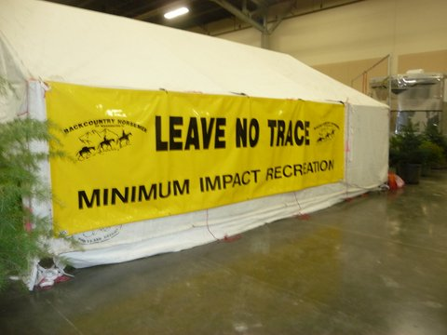Come see the Back Country Horsemen of Oregon LNT traveling training display at one of our next events, our display demonstrates proper techniques for riding and camping in the backcountry.

Become a BCHO member!

**Membership Application**

Yes! I would like to help preserve Horsemen’s rights to use stock on public lands. See also our web site: www.bcho.org/membership/form/.

____________________________________

(Print Name)

____________________________________  
(Address)

____________________________________  
(City) (State) (ZIP)

____________________________________  
(Telephone) (E–Mail)

____________________________________  
(Chapter Name)

BCHO Membership Dues

Single $35.00 _________

Family $45.00 _________

(Additional Chapter dues may be determined by individual Chapters)

**Liability Release:** Recognizing the fact that there is a potential for an accident wherever horse use is involved, which can cause injuries to horses, riders and spectators, and also recognizing that Back Country Horsemen of Oregon, Inc., including its chapters, officers, directors and or members cannot know the condition of trails or the experience of riders or horses taking part in trail rides or other Back Country Horsemen of Oregon functions, I do hereby release Back Country Horsemen of Oregon, Inc., its chapters, officers, directors and members from any claim or right for damages which might occur to me, my minor children or horses.

□ Send Highline via US Mail (Normally Sent to Email).

□ Okay to Send your Email to BCHA to receive National Newsletter.

Signed___________________________________  
Date______________________

For Questions email - membership@bcho.org

**MAIL your application to:**   
BCHO Membership  
PO Box 488   
Colton, OR 97017